
PERIODIC TEST - I (2023-24)
Subject: COMPUTER SCIENCE  Grade: XI |  | Max. Marks: 35  Time: 1 Hr 15 Mins

General Instructions

1. This question paper has 3 pages.

2. This question paper contains 4 sections, Section A to D.

3. All questions are compulsory.

4. Section A has 9 questions carrying 1 mark each.

5. Section B has 6 Very Short Answer questions carrying 2 marks each.

6. Section C has 3 Short Answer type questions carrying 3 marks each.

7. Section D has 1 question carrying 5 marks.

8. All programming questions are to be answered in Python Language only.
 | SECTION A |  |  | (9)
1. | What is the output of the given statement?  print(“Hello”+1+2+3) |  |  | 1
 | - Hello123 |  | - Hello6
 | - Hello+1+2+3 |  | - error
2. | What is the index value of the ‘i’ in the string ‘Learning’? |  |  | 1
 | - 5 |  | - 3
 | - 6 |  | - 7
3. | How many times will the following loop execute?  c=0  while c<20:  c+=2 |  |  | 1
 | - 20 |  | - 5
 | - 10 |  | - Infinite
4. | Which among the given statements is false about nested loops
 | - Nested loops in python must be of same kind, either all for loops or or while loops
 | b) In python, if two loops are nested, the outer loop and the inner loop can be of any kind(for and/or while)
5. | What will be the output of the following code:  x=10  y=0  while x>y:  print(x,y)  x=x-1  y=y+2 |  |  | 1
- 10 2
9 4
8 6
- 10 6
9 4
8 2
- 10 2
8 4
- 8 6
10 4
6. | When you execute a break command inside the inner loop of a pair of nested loops ... (mark the option that correctly completes this sentence): |  |  | 1
 | - ... both the inner loop and the outer loop are interrupted.
 | - … the outer loop is interrupted and the inner loop is not affected
 | - ... the inner loop is interrupted and the outer loop is not affected
 | - ... neither the inner loop, nor the outer loop are interrupted.
7. | Which of the following statement is correct in accessing each element of the string. |  |  | 1
 | a)  a=”Learning”  while (i):  print(i) |  | b)  a=”Learning”  for i in a:  print(i)
 | - a only |  | - both a and b
 | - b only |  | - none of the above
8. | What is the value of the var after the for loop completes its execution?  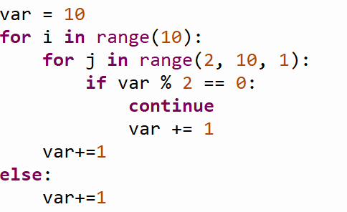 |  |  | 1
 | - 20 |  | - 21
 | - 10 |  | - 30
9. | The while loop is an entry-controlled loop. State True or False? |  |  | 1
 | SECTION B |  |  | (12)
10. | Write a program to accept a string and replace every blank space in it with hyphen.  Example:  Welcome to Python Programming  Welcome-to-Python-Programming |  |  | 2
11 | Predict the output:
 | a)  str1=”Good”  str2=”Morning”  print(str1,str2,end=’!!’)  print()  print(‘@’*5, end=’ ‘)  print(‘UAE’) |  | 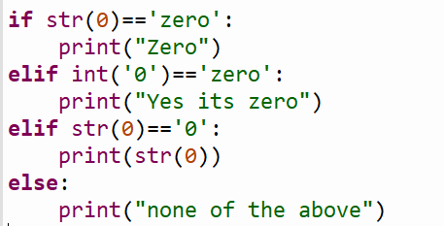  b) | 2
12. | Predict the Output:  n=15  m=30  for i in range(n,m):  for j in range(2,n):  if i%j==0:  break  else:  print(i) |  |  | 2
13. | Identify the syntax errors and rewrite the code. Underline every correction made.  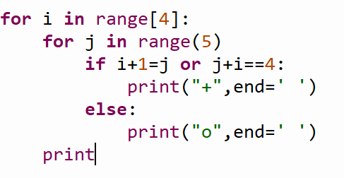 |  |  | 2
14. | What is the output of the following code:  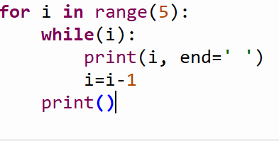 |  |  | 2
15. | Convert the following for loop into while loop:  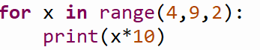 |  |  | 2
 | SECTION C |  |  | (9)
16. | Write a program to calculate the no of words and no of characters present in the input string |  |  | 3
17. | Write a program to produce the following pattern:  A  B C  D E F  G H I J  K L M N O |  |  | 3
18. | Write a program to accept a number and check if the is palindrome or not. |  |  | 3
 | SECTION D |  |  | (5)
18. | Write a menu driven program to perform the following based on the option selected by user:  1. Prime nos between m and n  2. Armstrong number or not  3. Exit |  |  | 5
***

